Date | 28.09.2026
Team ID | SWTID-2026-6482
Project Name | Auto Ticket Classification using Flow Designer

Requirement Analysis phase-II
4. Technology Stack

Technology Stack Overview
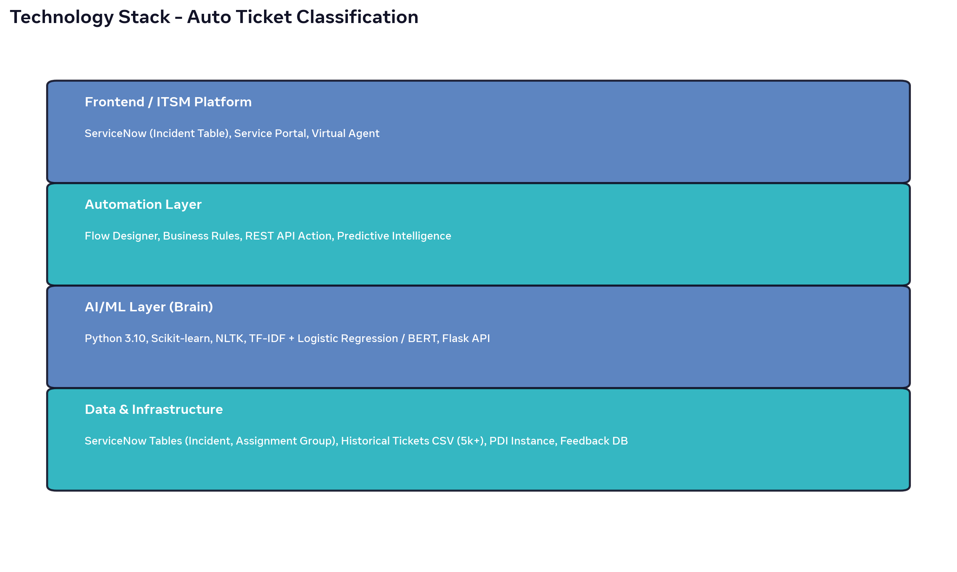
Layer | Technology / Tool | Purpose
Frontend / ITSM | ServiceNow Platform (Incident Table), Service Portal, Virtual Agent | Ticket creation interface, user portal
Automation | Flow Designer, Business Rules, REST API Step, Predictive Intelligence | No-code automation, trigger, API call, auto-update
AI/ML Brain | Python 3.10, Scikit-learn, Pandas, NLTK, TF-IDF + Logistic Regression / Naive Bayes, Optional: BERT / DistilBERT, Flask API | Train model, predict Category/Priority/Group, host as REST API
Data Layer | ServiceNow Tables (sys_journal, incident, sys_user_group), Historical Tickets CSV (Kaggle IT Tickets 10k), Feedback Table | Training data, storing predictions, retraining
Infrastructure | ServiceNow PDI (Personal Developer Instance), Python Flask hosted on Render / HuggingFace / Local, GitHub for versioning | Deployment, hosting, CI/CD
Monitoring | ServiceNow Dashboards, Performance Analytics, Email Notifications | Accuracy tracking, SLA monitoring, alerts

Alternative Stack Options
Option A (100% ServiceNow OOB): Use Predictive Intelligence instead of Python Flask - no external hosting needed but requires premium license.
Option B (Power Platform): Power Automate Flow + AI Builder + Dataverse for organizations using Microsoft stack.
Option C (Open Source): Jira + n8n Flow + Python FastAPI + HuggingFace Transformers for startups.

